
PM Poshan Shakti Nirman – Madhya Pradesh
Social Audit
User Manual
Web Portal (Parakh) | Mobile App (District GIS)
Academic Session 2026-27
Version 1.0 | October 2026

Contents
- 1. About this manual
- 2. Who uses the system (user roles)
- 3. The process at a glance
- Part A – Web Portal (Parakh): login, menu, forms, users, schools, assigning, verifying, reports
- Part B – Mobile App (District GIS): register, login, open the form, fill the audit, submit

1. About this manual
This manual explains, step by step, how to use the PM Poshan Social Audit system. The system has two parts:
- Web Portal (Parakh) – used by officers on a computer to create users, choose schools, assign schools to inspectors and check the results.
- Mobile App (District GIS) – used by the inspector at the school to fill in the audit form and take photos.
Every step has a short explanation and a screenshot. Follow the steps in the same order.

2. Who uses the system
User role | What they do
State Admin (State Coordinator) | Controls the whole PM Poshan setup for the State.
State Nodal Officer (2) | One for PM Poshan and one for Social Audit.
District Nodal Officer (2) | One for PM Poshan and one for Social Audit, at district level.
Block Coordinator | Looks after the Social Audit at block level.
VSA (Village Social Animator) | Fills in the report after the Gram Sabha meeting.
Inspector | Visits the assigned school and fills in the audit form in the mobile app.

3. The process at a glance
- Login to the Parakh web portal (Department login).
- Create users (nodal officers, reporting officers, inspectors).
- Check the School List – nominated and non-nominated schools.
- Assign schools to an inspector for Social Audit.
- Inspector fills the audit form in the District GIS mobile app and submits it.
- Verify the Social Audit on the web portal and view Reports.

Key facts for 2026-27 (from the State Social Audit Society letter dated 05-10-2026)
- Social audit of 7 schools in every block of every district – 2,191 schools in the State.
- Each school is audited over 2 days by one VSA. A VSA is not given a school in his or her own Gram Panchayat.
- The audit checks documents, the school in person, talks with parents (PTA) and self-help groups, and the full meal process from cooking to serving.
- All audit steps must be completed by 30 November 2026.

Part A – Web Portal (Parakh)
Use a computer for all steps in this part.

Step A1: Login
- Open https://geoportal.mp.gov.in/parakhweb/ in your browser (or scan the QR code given in the training material).
- On the Login screen, click Department.
- Enter your Username and Password, then click Login.
- You will see the Dashboard. It shows how many users are registered for each role.
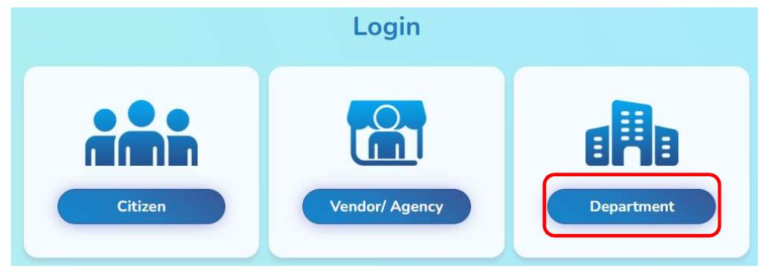
Figure 1: Login screen – click Department
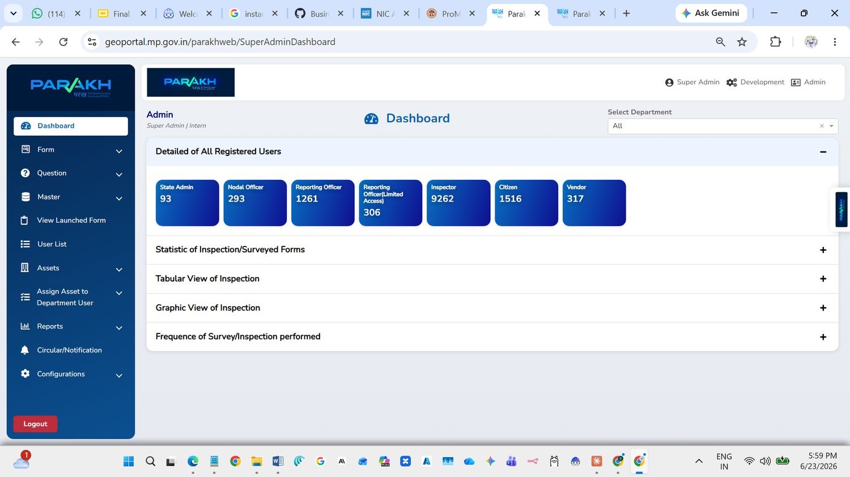
Figure 2: Dashboard after login

Step A2: Know the menu
The menu is on the left side of the screen. The options you will use most are:
- Master – Create Designation and Create User.
- View Launched Form – see the PM Poshan audit form.
- Validate User – approve new users.
- User List – see all users.
- Schools – School List.
- Assign Schools For Social Audit – give schools to an inspector.
- Verify Social Audit – check submitted audits.
- Reports – view and download reports.
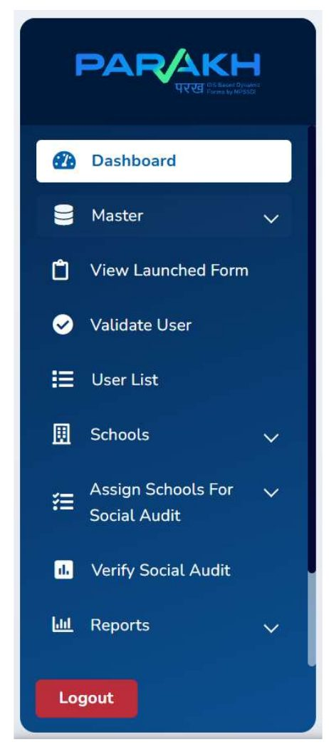
Figure 3: Parakh menu

Step A3: View the audit form
The PM Poshan Social Audit form is already created and launched. You can only view it here.
- Click Form to see the Form List (form name, type and status).
- Click View Launched Form. The PM Poshan Shakti Nirman Yojana form appears as a card.
- Click View Form to preview all the questions, or View Report to see its report.
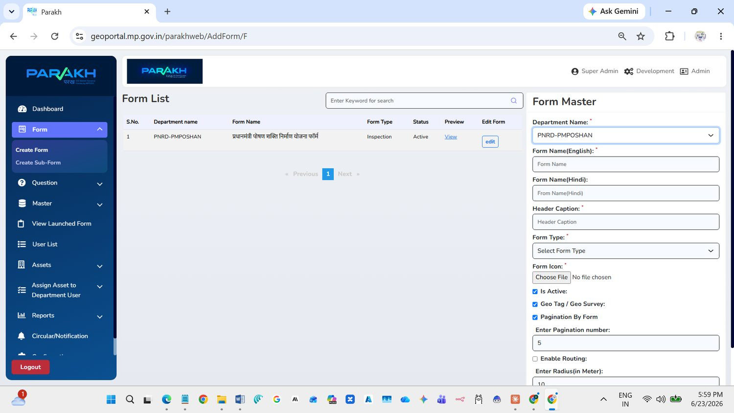
Figure 4: Form List
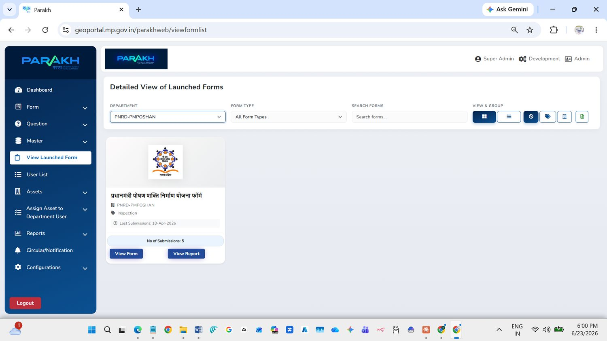
Figure 5: View Launched Form – Super Admin
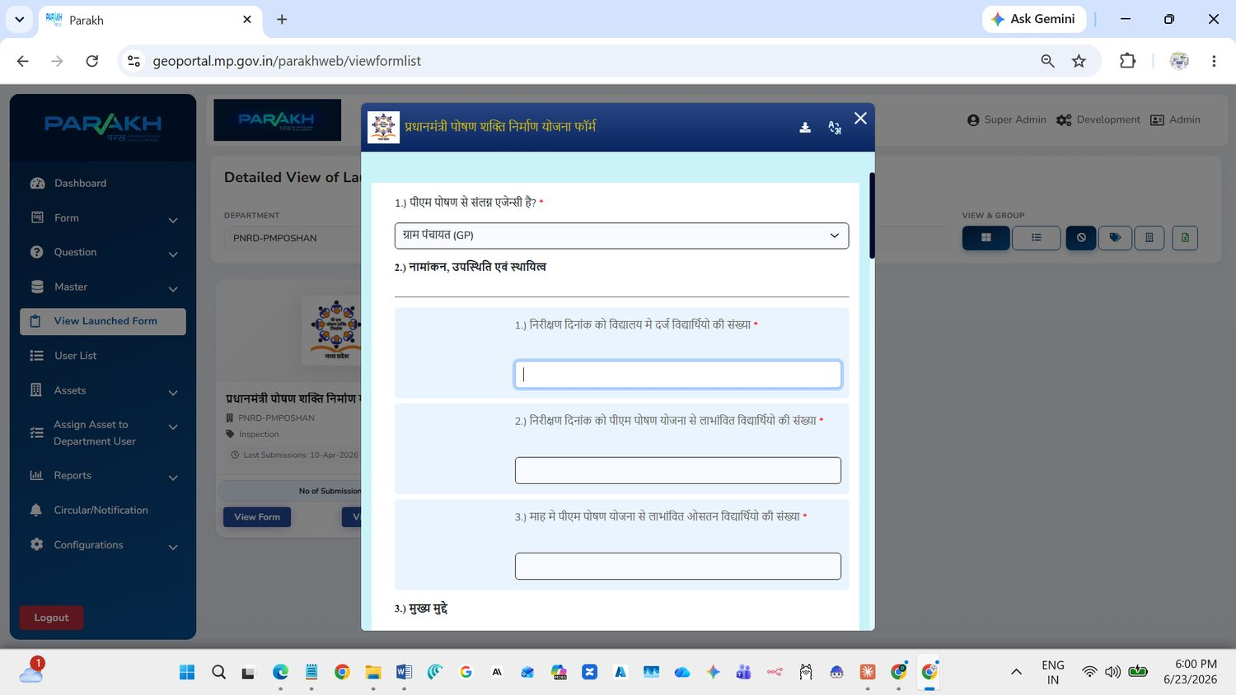
Figure 6: Preview of the form questions
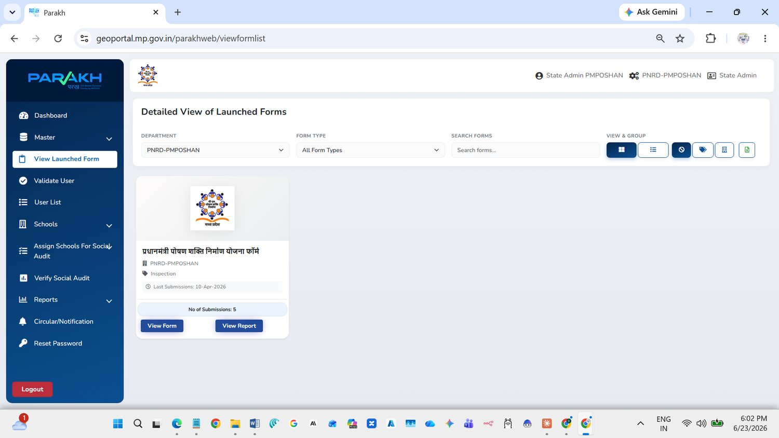
Figure 7: View Launched Form – State Admin PM Poshan

Step A4: Create a designation
A designation is the job title of a user (for example, District Nodal PM Poshan). Create it before creating users.
- Click Master → Create Designation.
- The existing designations are shown in the list on the left.
- On the right, type the Designation Name, keep Is Active ticked and click Add.
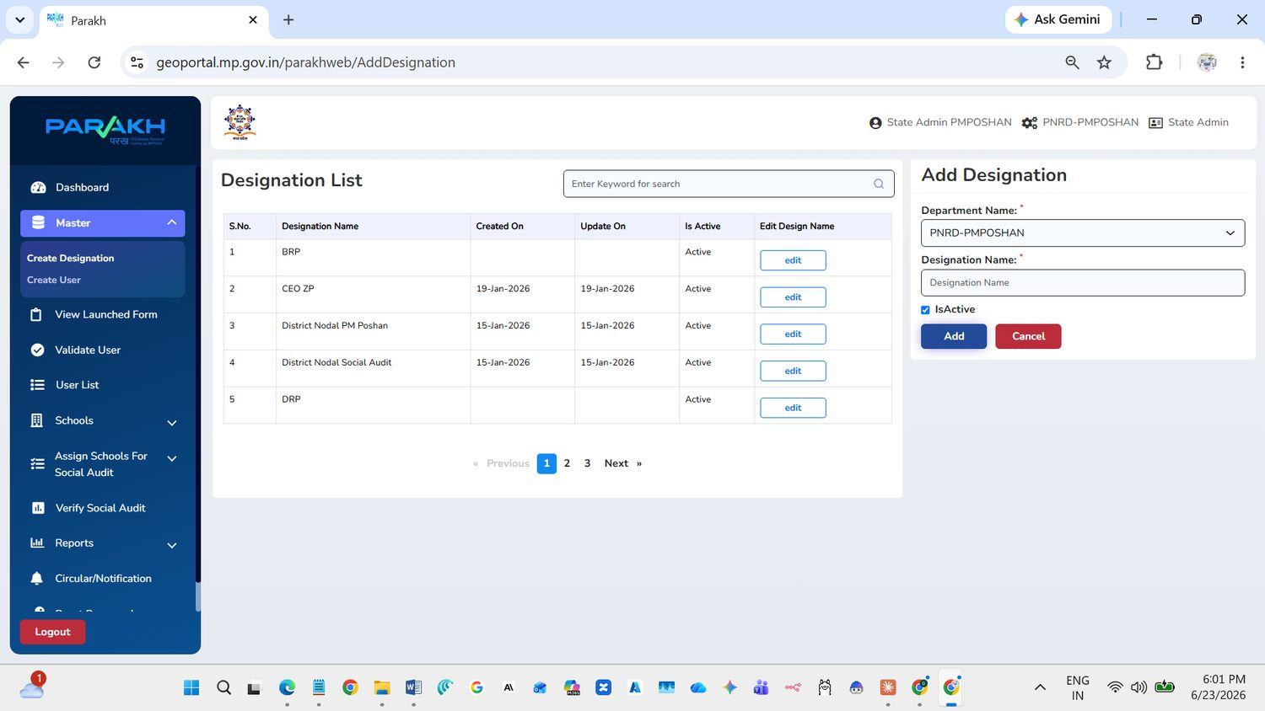
Figure 8: Designation List and Add Designation

Step A5: Create a user
Use this screen to create nodal officers, reporting officers and inspectors.
- Click Master → Create User.
- Department Name is PNRD-PMPOSHAN.
- Fill in First Name, Last Name and Mobile number. Email and Father’s Name are optional.
- Choose the Designation and the User Type/Role (for example, Inspector).
- Type a User Name, choose the Gender and click Add User.
Tip
- Fields marked with a red star (*) must be filled in.
- Click Cancel to clear the form.

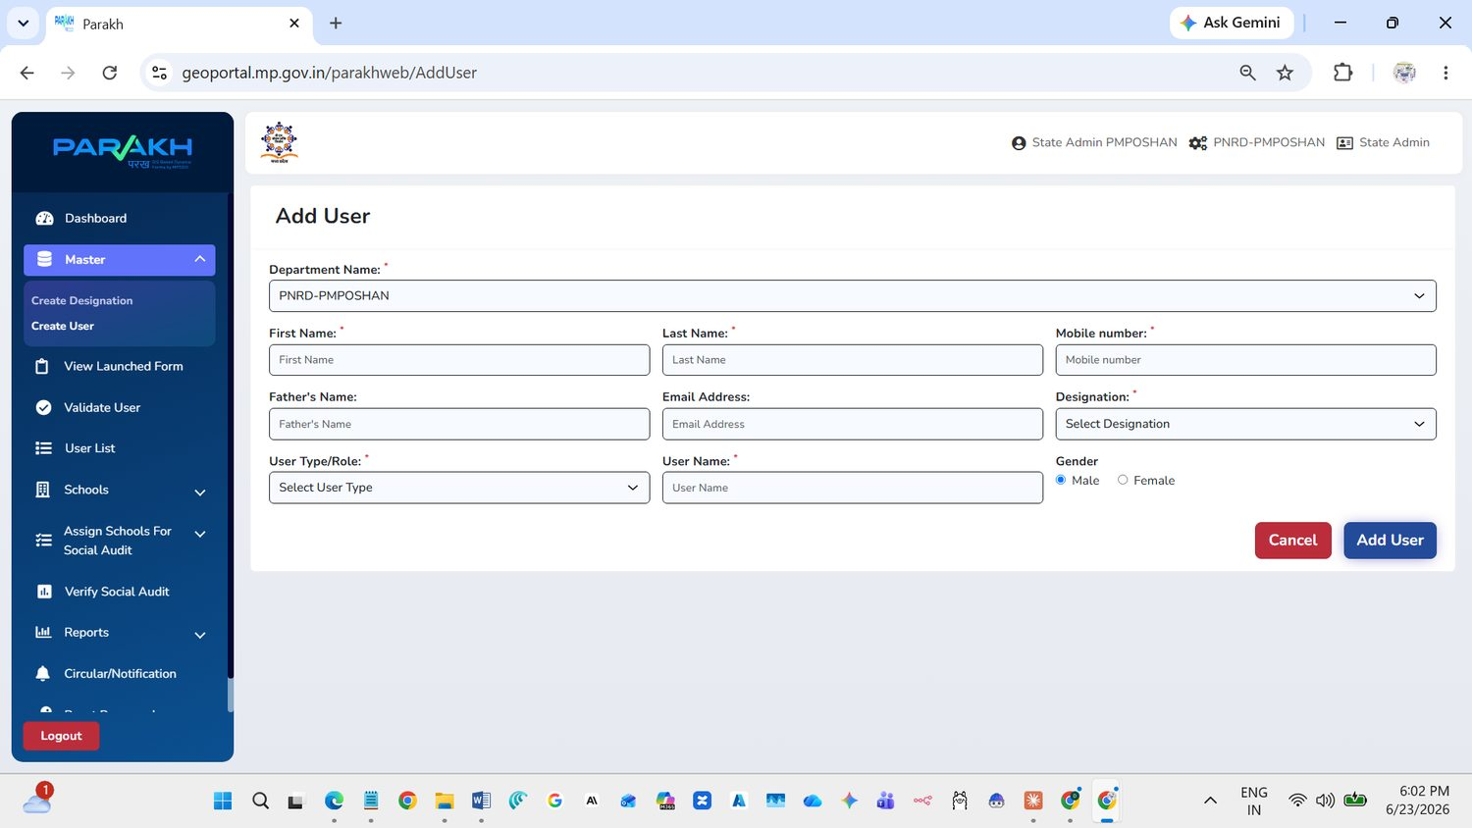
Figure 9: Add User form

Step A6: See the User List
- Click User List.
- Choose the User Type/Role (Nodal Officer, Reporting Officer or Inspector) and, if needed, the District.
- Click Search. The list shows name, mobile number, email, district, reporting officer and user name.
- Use the switch to activate or deactivate a user, edit to change details, and Export to Excel to download the list.
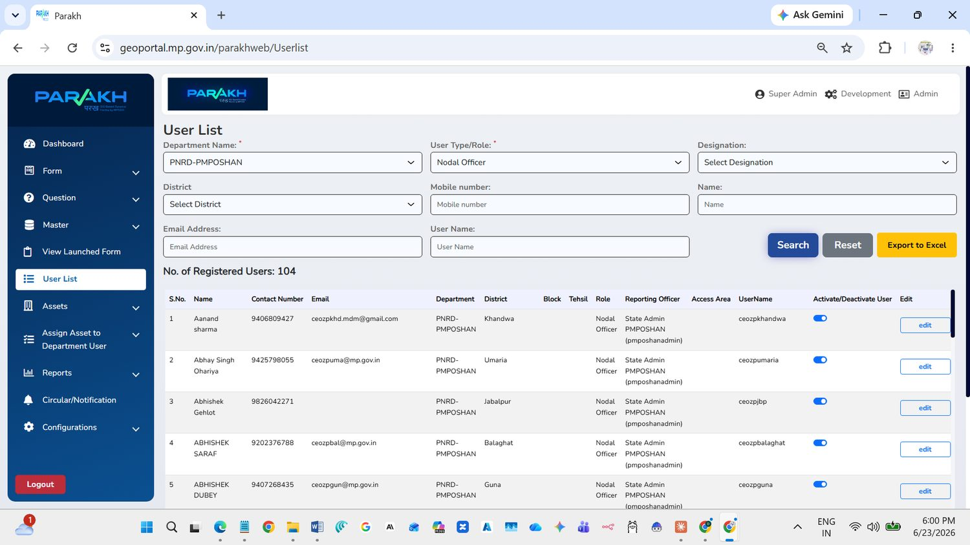
Figure 10: User List – Nodal Officers (Super Admin view)
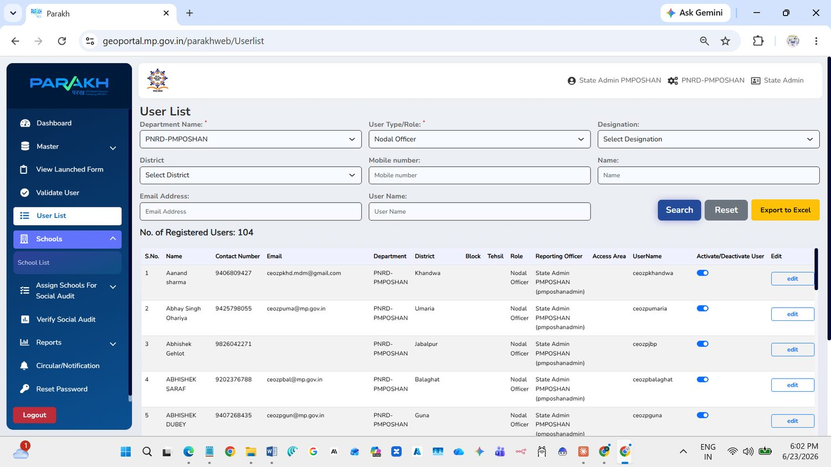
Figure 11: User List – Nodal Officers (State Admin PM Poshan)
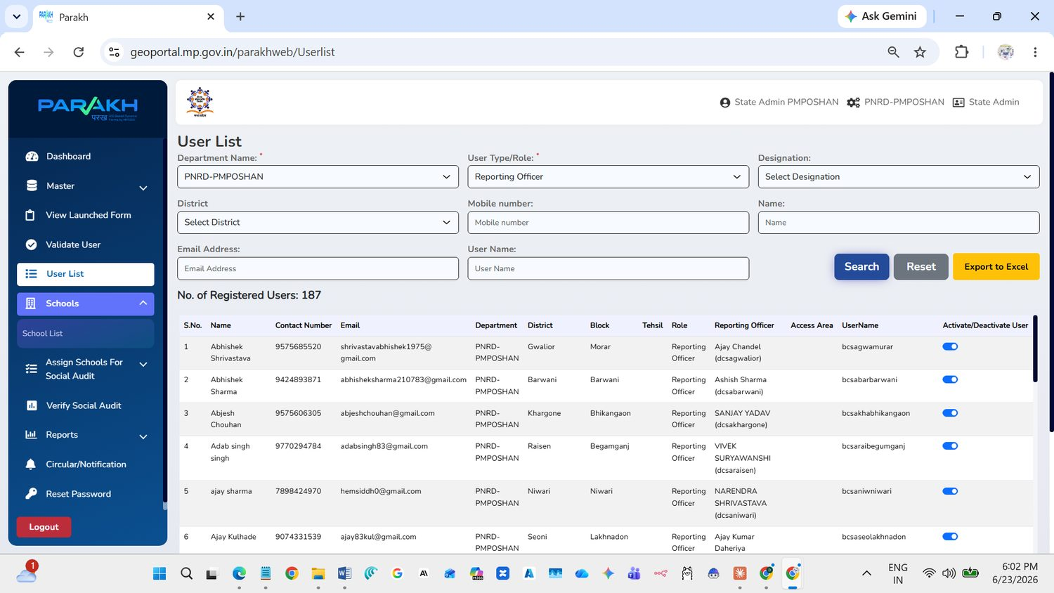
Figure 12: User List – Reporting Officers
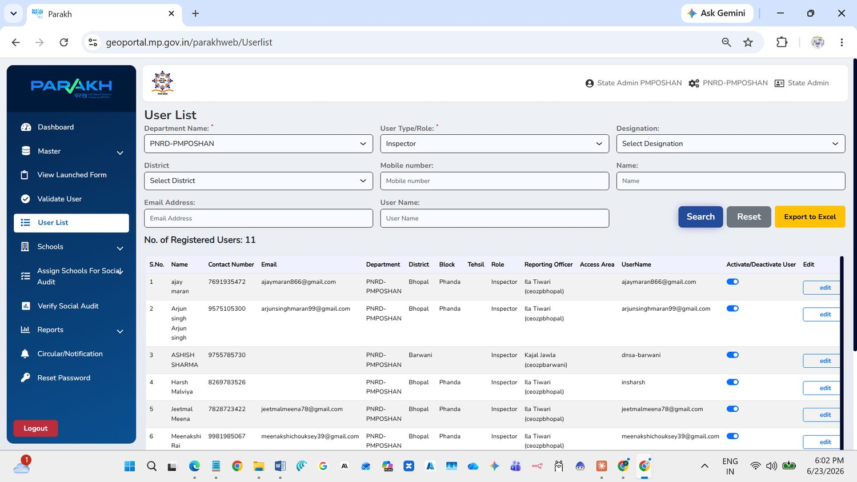
Figure 13: User List – Inspectors

Step A7: Check the School List
- Click Schools → School List.
- Select District and Block. Until you do, the screen shows “No record found”.
- Two tabs are shown: Non-Nominated and Nominated. Nominated schools are the ones selected for the Social Audit (7 per block).
- To select a school for the audit, use the button in the Move to Nominated column.
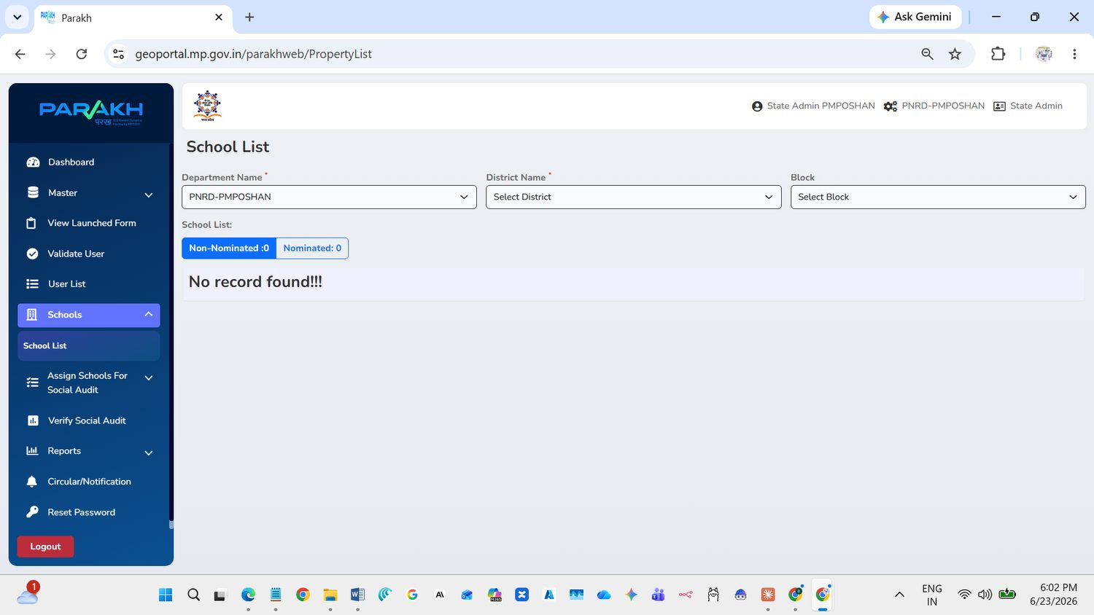
Figure 14: School List before selecting district and block
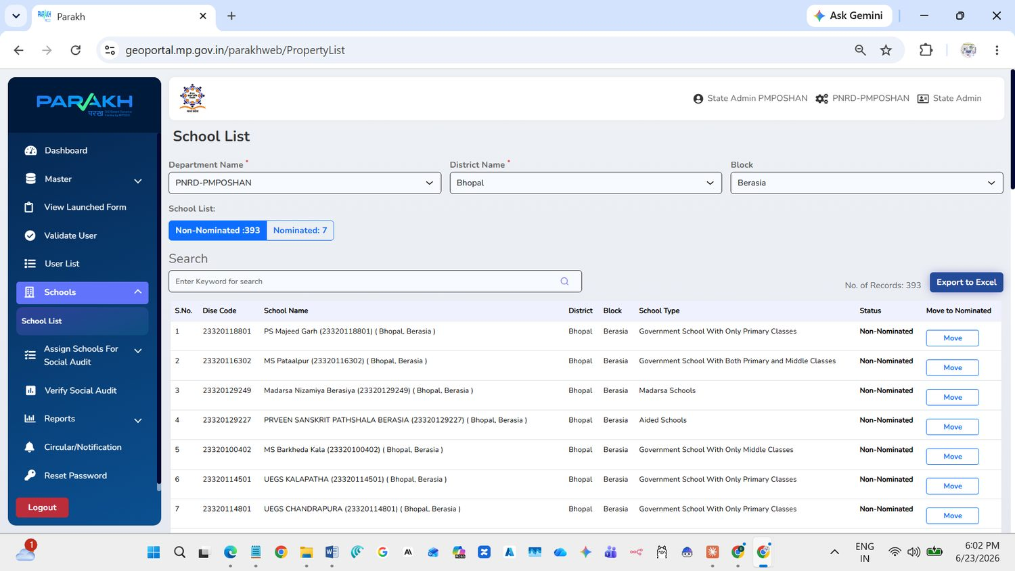
Figure 15: School List for a district and block

Step A8: Assign schools for Social Audit
Here you give nominated schools to an inspector.
- Click Assign Schools For Social Audit → Assign For Inspection Social Audit.
- Select District and Block.
- In Form, choose the PM Poshan Shakti Nirman Yojana form.
- In Department User, choose the inspector.
- Keep Is Allotted = No to see schools not yet given to anyone, then click Search.
- Tick the box in front of each school to assign. Unassigned schools show the status “Unassigned”.
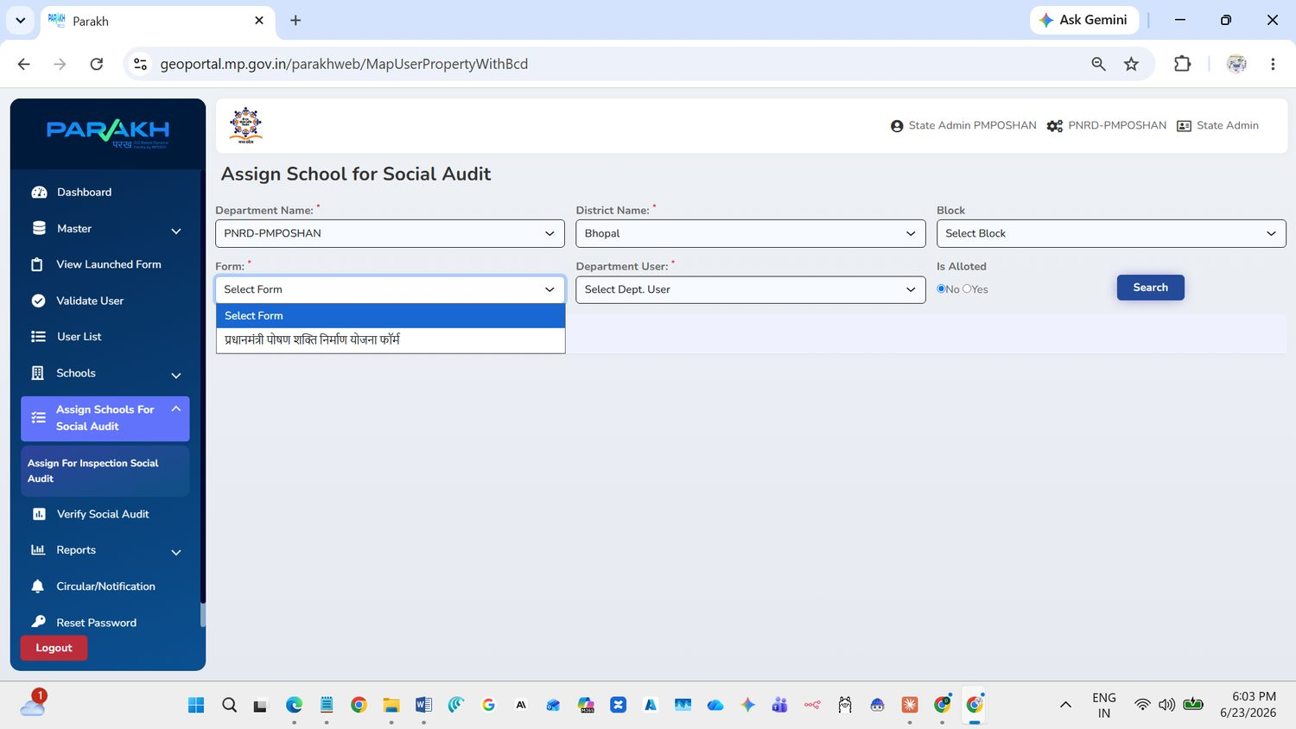
Figure 16: Assign School – choose the form
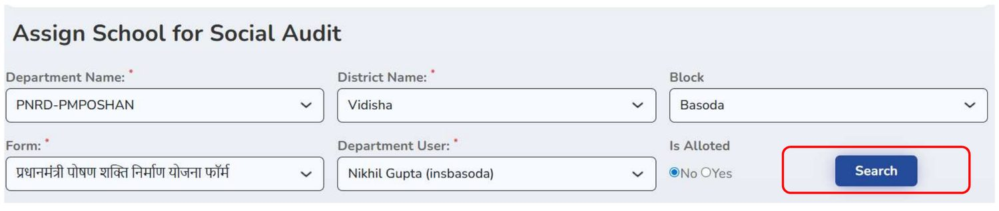
Figure 17: Select district, block, form and inspector, then Search
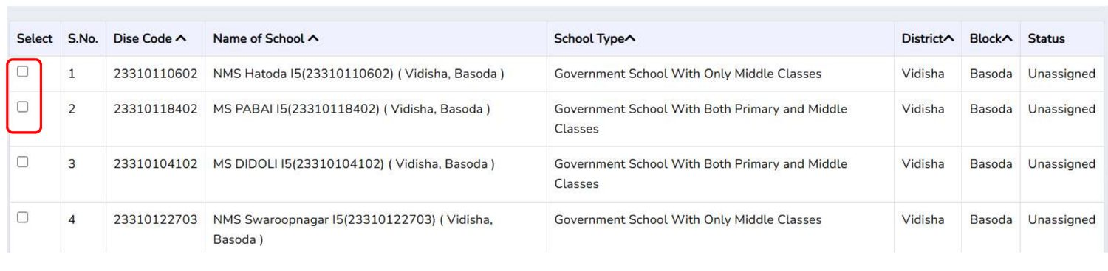
Figure 18: Tick the schools to assign

Step A9: Verify Social Audit
- Click Verify Social Audit.
- Choose the District, the Reporting Hierarchy (the officer) and the Status.
- Click Search to see the audits.
Status options include: Assigned, Saved as Draft, Submitted, Approved, Rejected and others.
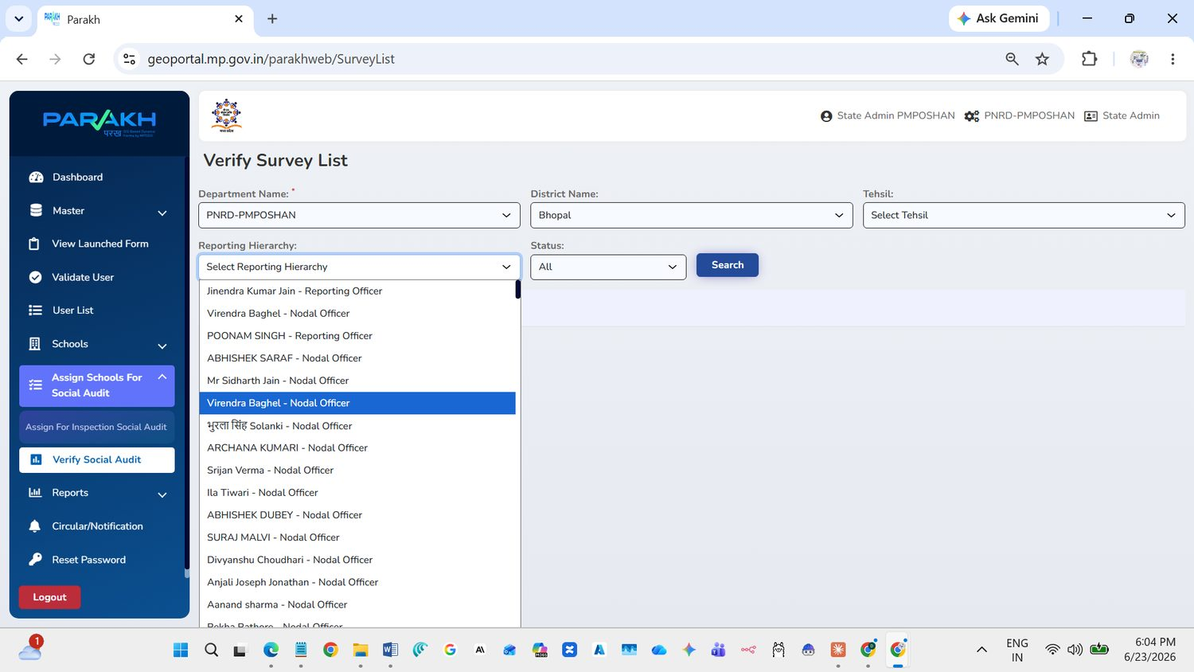
Figure 19: Verify Survey List – choose the reporting officer
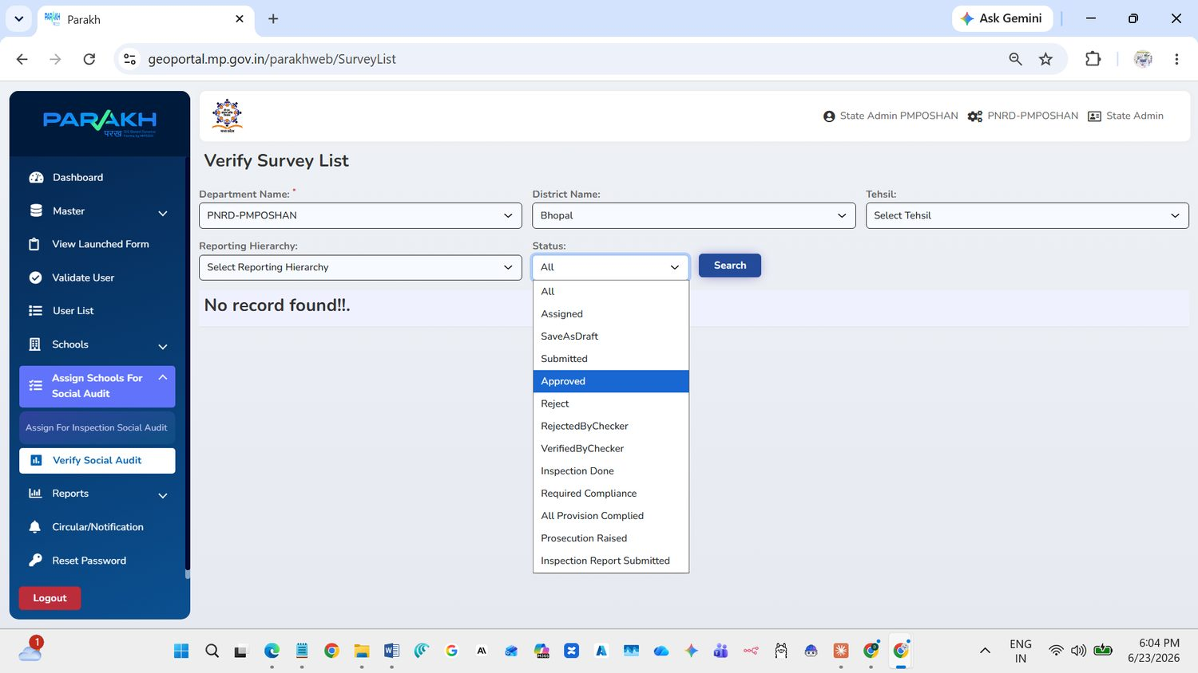
Figure 20: Verify Survey List – choose the status

Step A10: View reports
- Click Reports → Reports: Details of Survey & Inspection.
- Select District, Reporting To, User, Start Date, End Date and Status.
- Click View. The list shows each school, who it was assigned to, dates and status.
- Click Export All to Excel to download.
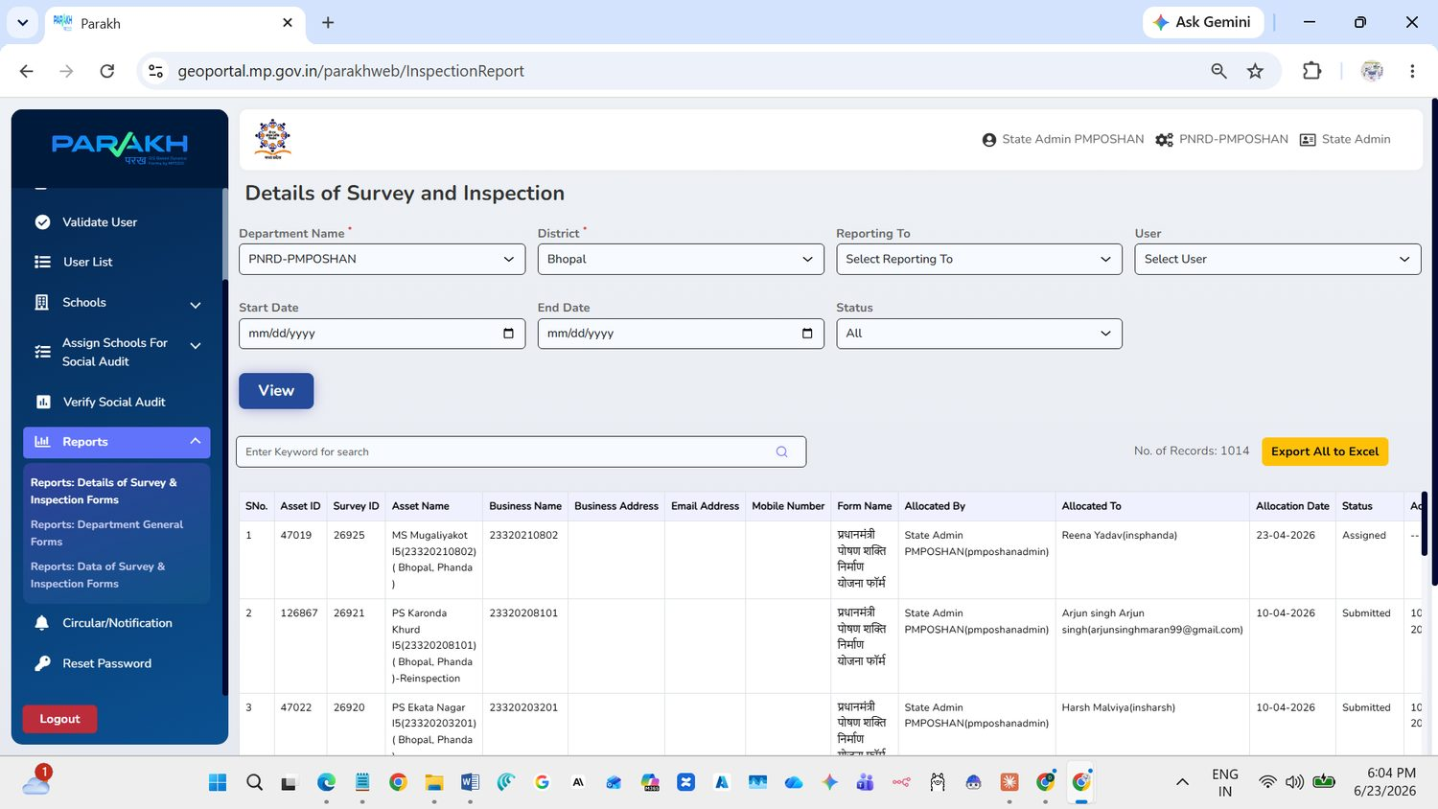
Figure 21: Details of Survey and Inspection report

Part B – Mobile App (District GIS)
Use an Android phone for all steps in this part.

Step B1: Install the app
- Open Google Play Store and search for District GIS (MPSeDC, Dept. of Science and Technology, Govt. of MP).
- Tap Install, then Open.

Step B2: Register as a new user
If you do not have a login yet, register first.
- Open the app, choose your District, then tap Department.
- Tap New Registration.
- Enter First Name, Last Name, Mobile Number and Contact Email (Username).
- Choose Department, District and, if shown, Tehsil and Block.
- In Approval To, choose the officer who will approve you, then tap Submit.
- Enter the OTP received on your mobile and tap Submit.
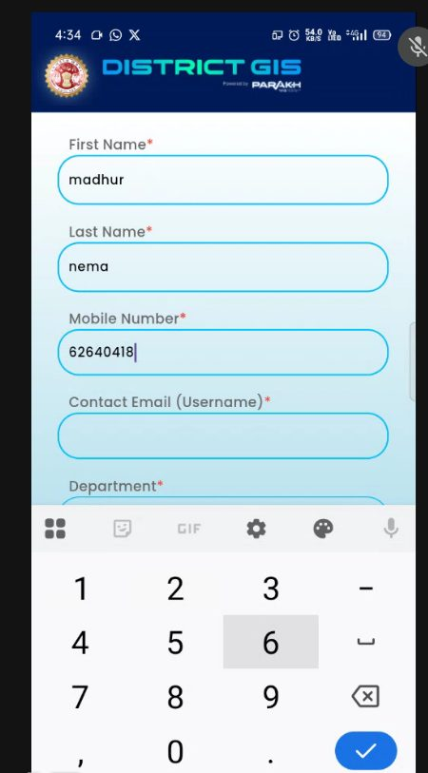  Figure 22: Enter your name and mobile number | 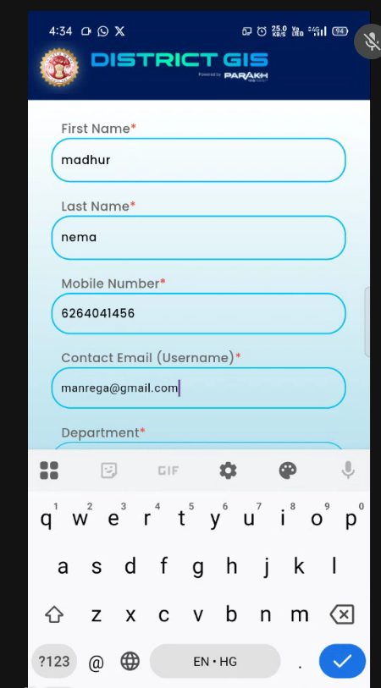  Figure 23: Enter your email (username) | 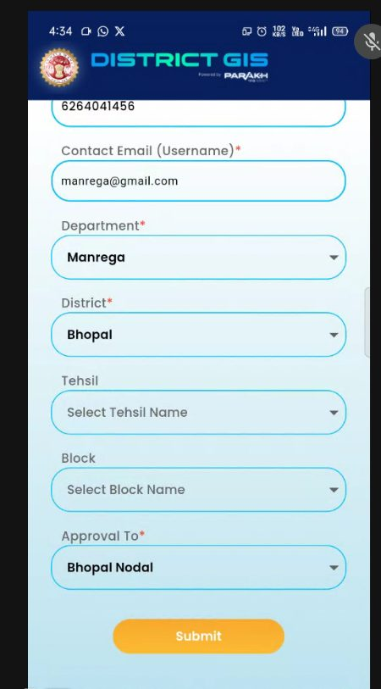  Figure 24: Choose department, district and approver
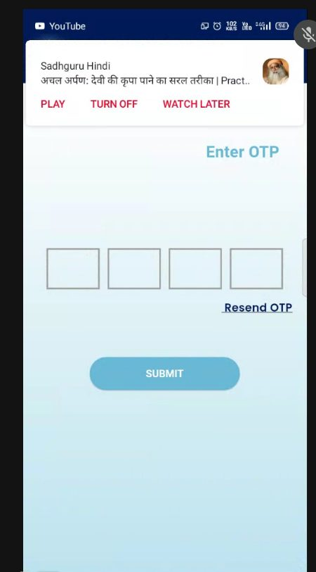  Figure 25: OTP screen | 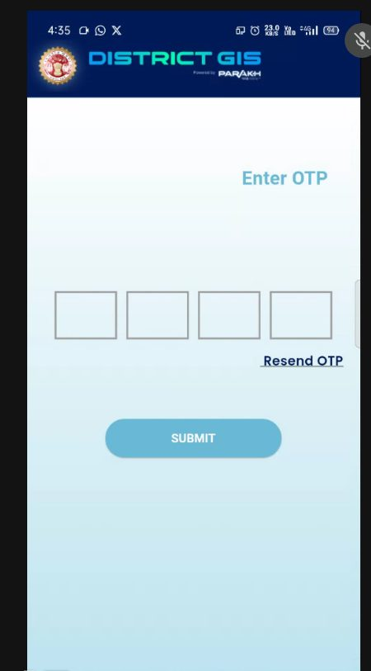  Figure 26: Enter the OTP | 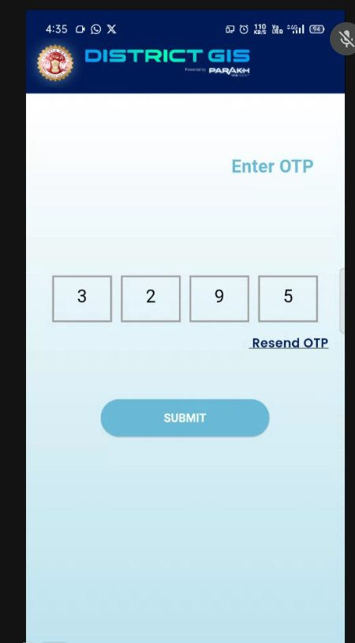  Figure 27: OTP entered – tap Submit

Step B3: Approval of the new user
Your approving officer opens the web portal, goes to Validate User, checks your details and approves you. You can log in only after this approval.
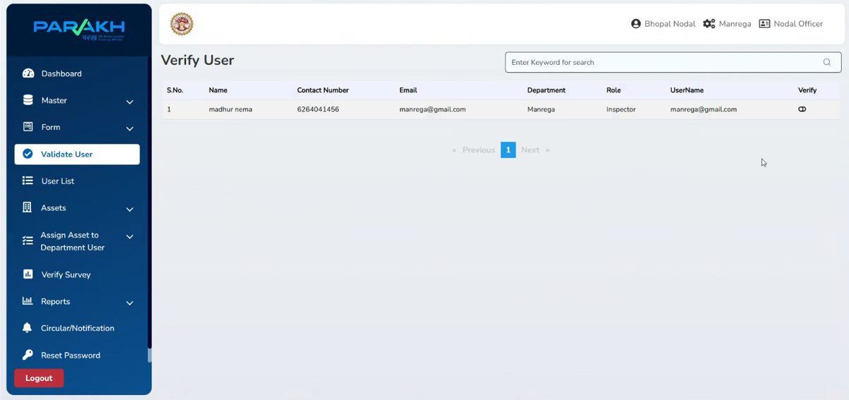
Figure 28: Validate User screen on the web portal

Step B4: Login
- Open the app, choose your District and tap Department.
- Enter your Username (Email) and Password.
- Tap Login. You can also use Login with OTP. If you forget the password, tap Forgot Password?.
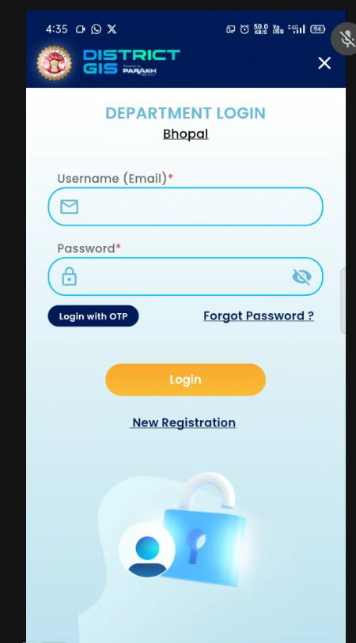  Figure 29: Department Login screen | 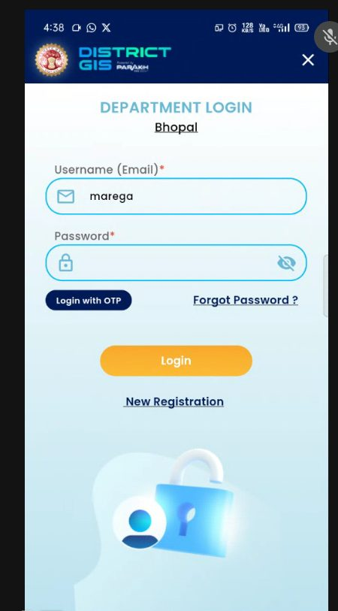  Figure 30: Enter username | 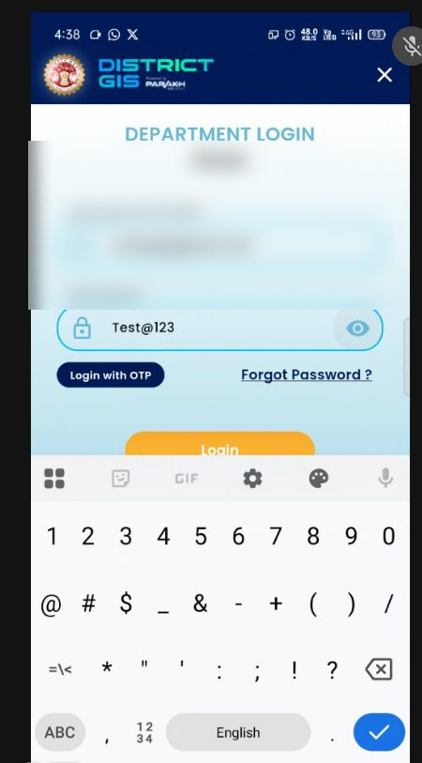  Figure 31: Enter password and tap Login

Step B5: Home screen
After login you will see the home screen with these options:
- Modules – open the forms assigned to you.
- Draft Saved – continue an audit you saved as draft.
- Work History – see audits already done.
- Profile – see your profile.
- Navigate to Point of Interest – find places on the map.
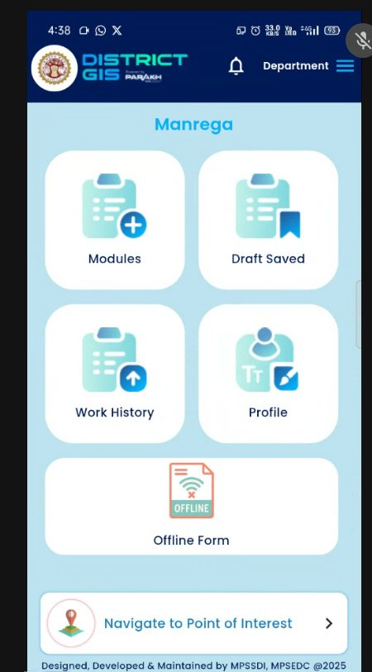
Figure 32: Home screen

Step B6: Open the audit form
- Tap Modules.
- Tap Inspection to open the list.
- The list shows the schools assigned to you. Tap the school you are going to audit.
- The PM Poshan Shakti Nirman Yojana form opens.
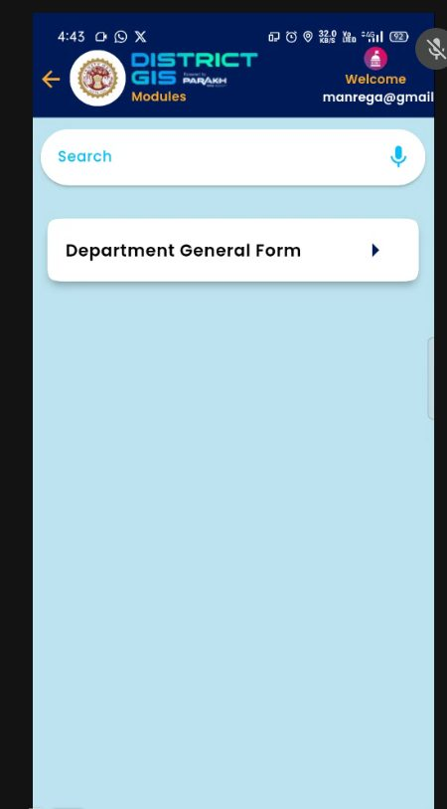  Figure 33: Modules screen | 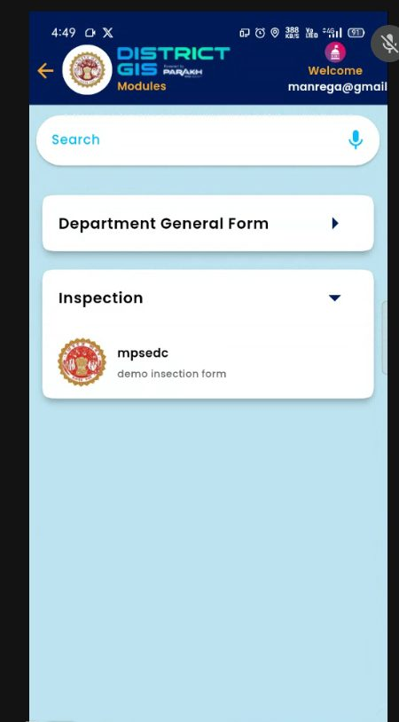  Figure 34: Inspection list opened | 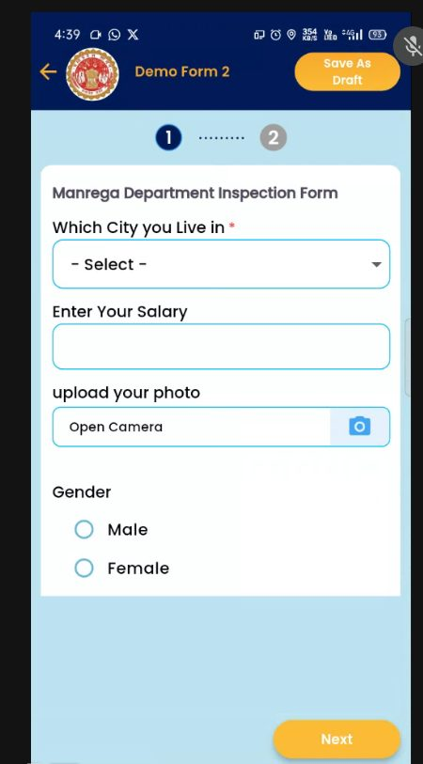  Figure 35: The form opens
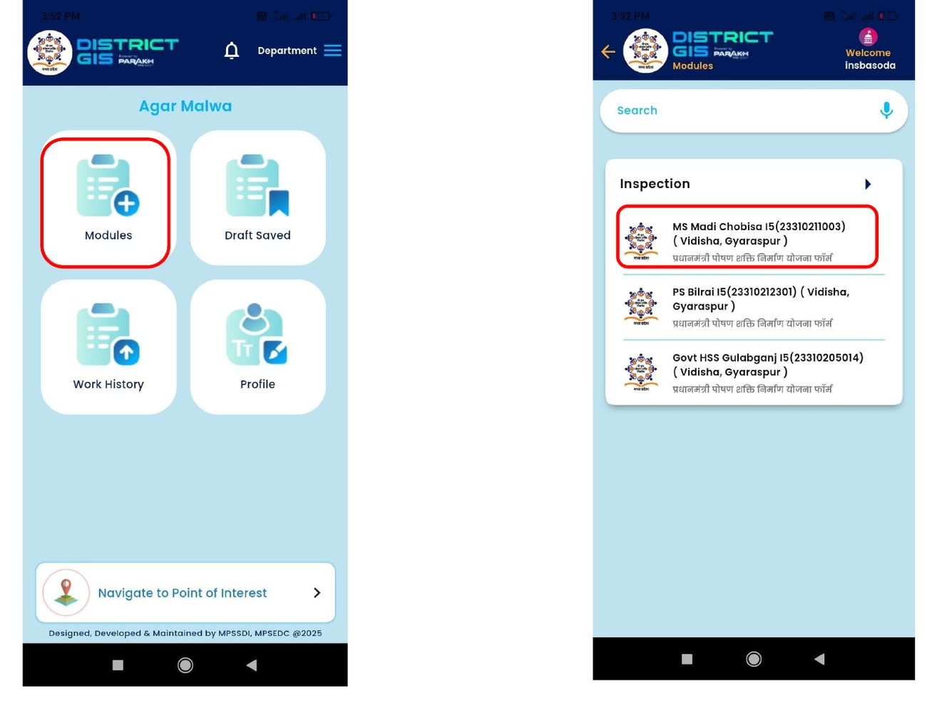
Figure 36: Tap Modules, then tap the assigned school

Step B7: Fill in the audit form
The form has 6 steps. Answer every question (Yes / No) and write a remark. Questions marked with a red star (*) must be answered.
Buttons on every step
- Save As Draft (top right) – saves what you have filled so you can finish later.
- Next / Previous – move between steps.
- Submit – on the last step, sends the audit.

Step 1 – Enrolment, attendance and sustainability
Enter the number of students enrolled on the inspection day, the number of students who received PM Poshan meals that day, and the monthly average. Then answer the key questions, such as whether the self-help group (SHG) is registered under SRLM/NRLM, whether it has a contract, and whether it receives the regular cooking cost.
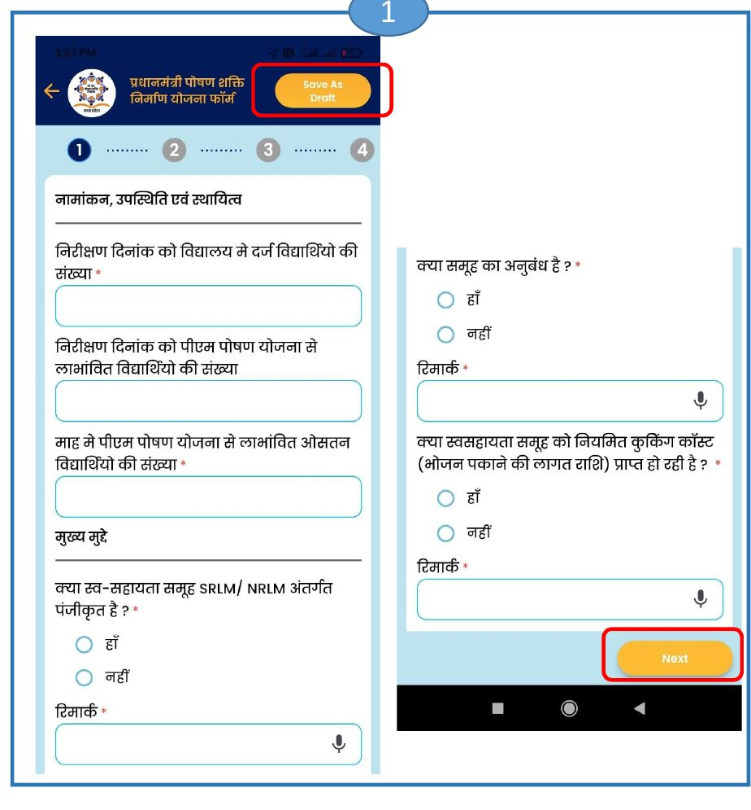
Figure 37: Form Step 1 – tap Next to continue

Step 2 – Cooks, food grains and menu
Questions about regular honorarium for cooks, regular supply of food grains to the school or agency, whether meals follow the PM Poshan menu, whether the menu is written on the school wall, and whether drinking water is available.
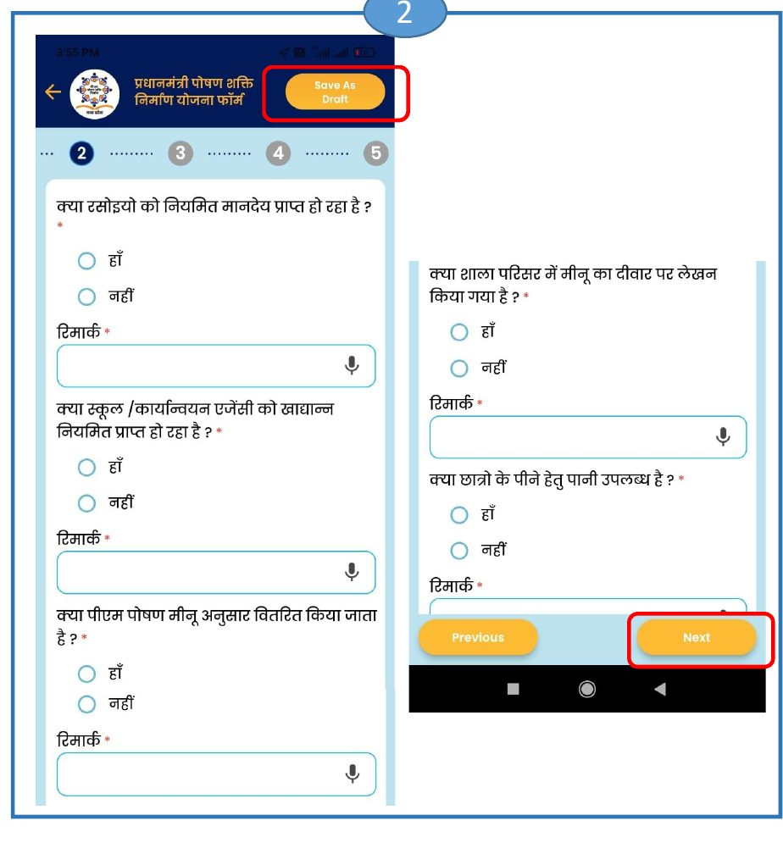
Figure 38: Form Step 2

Step 3 – Kitchen and health
Questions about the kitchen garden, a pucca kitchen-cum-store, a food sample being kept, health check-up and iron-folic acid / de-worming tablets, and enough cooking and serving utensils.
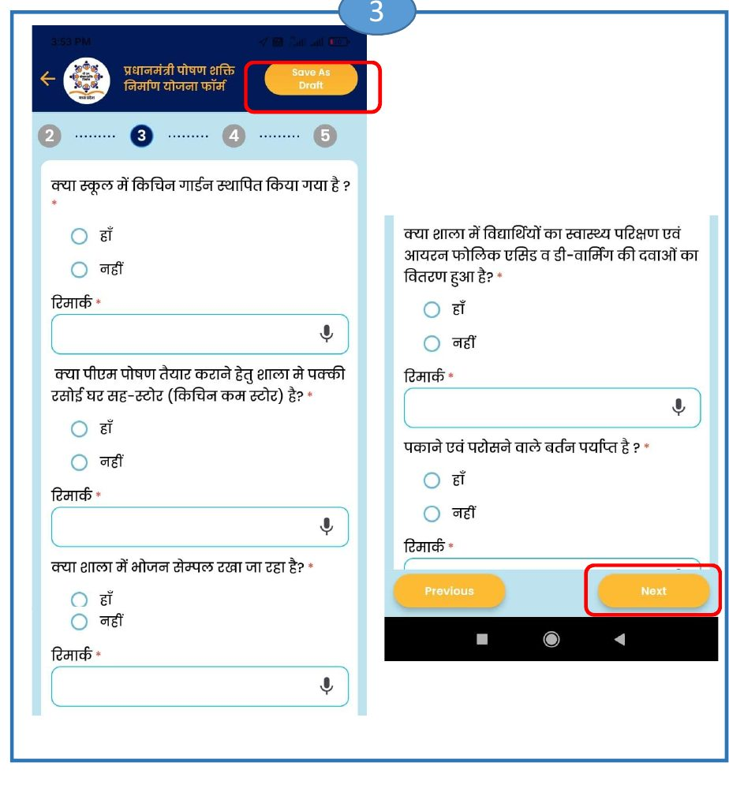
Figure 39: Form Step 3

Step 4 – Serving and monitoring
Questions about enough plates to eat from, food served in plates, regular inspection by officers, whether the number of beneficiary children is sent to the AMS portal, and efforts for Tithi Bhojan.
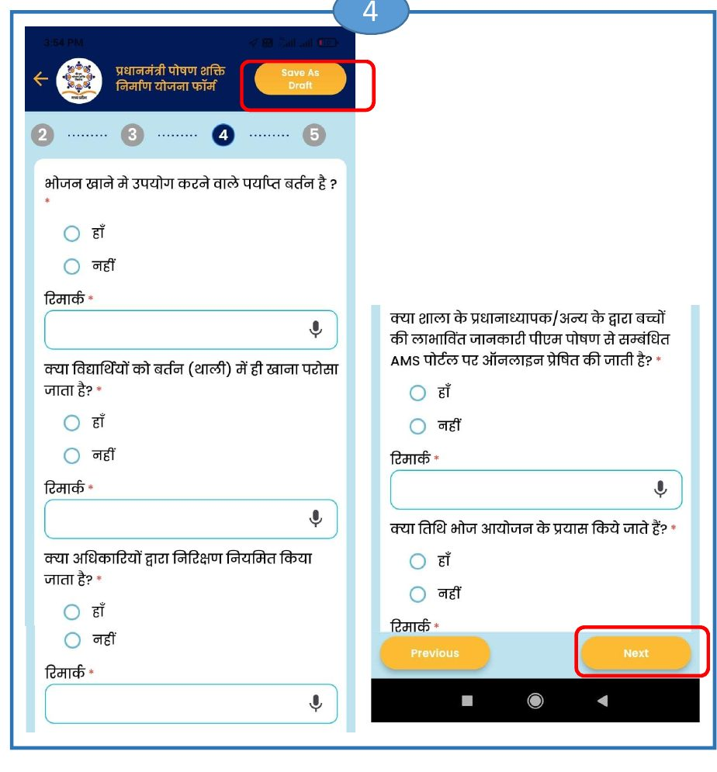
Figure 40: Form Step 4

Steps 5 and 6 – Discrimination, fuel and photos
Step 5: whether there is any gender or caste discrimination while cooking or serving, and whether the cooking fuel is gas based. Step 6: take photos using Open Camera – school premises, kitchen shed, the Gram Sabha meeting and others. Use Add More for extra photos and View List to see them. Check everything, then tap Submit.
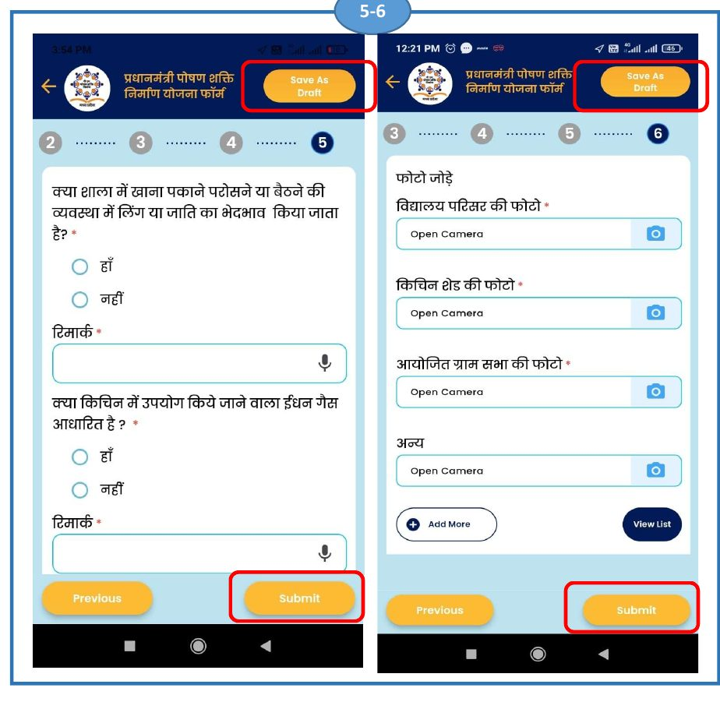
Figure 41: Form Steps 5-6 – tap Submit at the end

Step B8: After you submit
- The audit appears under Work History on the home screen.
- The officer can now see it under Verify Social Audit on the web portal (Step A9) and in Reports (Step A10).
- Audits saved as draft stay under Draft Saved until you submit them.

